If you want to add a source file to the Team Project, add the new file in your copy of the Team Project Folder which should appear in your Package Explorer after you cloned the project from my Github repository. Or you can edit a source file that we already have and I can review the changes.

( I added NedTest2 below and will push it to the remote Repository/TeamRockProject Folder)

If you push a separate project like Hospital in the image below, then that gets sent to the remote working directory, and is displayed alongside the TeamRockProject folder. If I want, I can then import it to my Package Explorer and push it to the Team Repo so that everyone will get it.

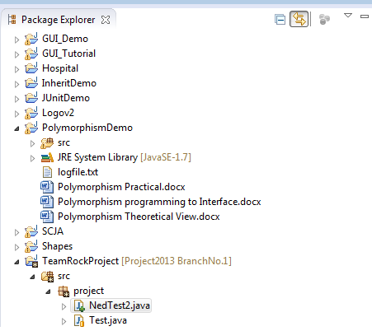

If you get any “fast-forward errors” when pushing stuff to me then that is a synching issue that can be resolved by the person hosting the repository (me) pulling from the remote repository to synch with my local. The person getting the error should then be able to push their changes to the remote repository.